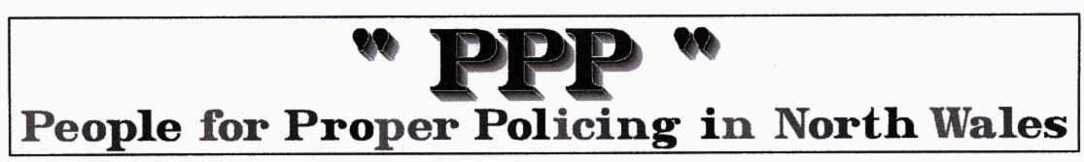
First crackhouse closure for Anglesey
This story from the North Wales chronicle … AND verbatim from the NWPF website!
North Wales Police have today successfully obtained the first crackhouse closure on Anglesey following an investigation into illegal drug activity.

After consulting with various partner agencies, officers attended Llangefni Magistrates Court today (Wednesday 14th November) where the order was granted to close 3 Tan Capel in the town.

This has resulted in the house being closed down and boarded up for a minimum of three months until February 2008. It is now an offence for anyone to enter or use the premises under the Anti-social Behaviour Act 2003.

Neighbourhood Police Sergeant Guy Blackwell says: “I am extremely pleased that we have managed to secure this closure order today, the first ever approved in Anglesey and Gwynedd. It’s as a result of a long investigation into drug-related offences at the address during which two warrants have been executed under the Misuse of Drugs Act. The effect that this illegal activity had on the local community, disrupting their day to day lives and placing them in fear, will not be tolerated.''

He added: “North Wales Police is committed to making neighbourhoods safer and more pleasant places to live. The supply of drugs affects the quality of life for everyone and we will continue our war using every available power for enforcement.”

South Anglesey District Commander, Inspector Pickering added "The support from the public has been fundamental in achieving this closure order."

The PPP comments……We expect this to be the first of many!…… at a Police Authority public meeting in Llangefni local residents described the almost 24 hours a day LONG TERM drug trafficking they had witnessed on this estate. Inspector Pickering discussed the issue with these residents and obviously effectively followed this issue through to this conclusion. We congratulate him and Sgt Blackwell and the team.

The PPP are concerned about the following aspects of this case ……the trafficking was long term which means many young people and others will have been recruited and consolidated into the drug culture and associated criminal activities. Such activities are WELL KNOWN in most North Wales communities so why are they left to continue for so long?

We now have a house boarded up and wasted and an eyesore on the estate for what purpose?. The tenants/owners/ traffickers…….who were they? where are they now? what penalties have they suffered?…….have their ill gotten financial and property gains been taken from them ( for use in the community they abused) … under the new legislation??

We repeat …. PREVENTION is so much better than DETECTION … particularly relating to drug trafficking and addiction. The COMMUNITY police officers MUST prioritise rheir developing a detailed knowledge of these activities in their communities.

